EE335 Electronics, 2018_19 Fall

BJT Amplifier “Design Question”

R. Köprü, Jan. 6 2019

**Q1.** The BJT amplifier circuit seen in fig.1.a. is to be designed so that it can process the input voltage Vi to yield the output voltage Vo whose waveforms are given as in fig.1.b. Determine the supply voltage Vcc of the circuit.

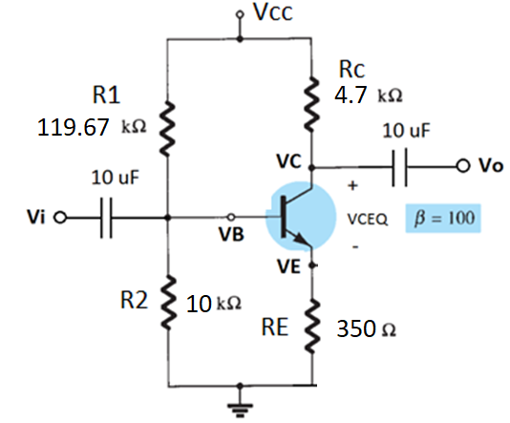Fig. 1.a.

t (ms)

|  |
| --- |
| Vo  Vi  1 V  Vom=13 V  Vi, Vo (V)  **1.**  **0.0**  **0.75**  **0.50**  **0.25**  Fig. 1.b. |

**Solution:**

From the plot, we measure that the amplitudes of Vi and Vo as Vim=1 V and Vom=13 V, respectively. (*We assumed that half centimeter in vertical axis corresponds to 1 V*). Therefore the mathematical expression for them can be written as follows:

$$v_{i}\left(t\right)=V_{im}\sin\left(2π1000t\right)=1\sin\left(2π1000t\right), V$$

$$v_{o}\left(t\right)={-V}_{om}\sin\left(2π1000t\right)=-13\sin\left(2π1000t\right), V$$

The numerical value of the AC voltage gain is thus can be written as

$$A_{v}=\frac{v_{o}}{v_{i}}=\frac{-13\sin\left(2π1000t\right)}{1\sin\left(2π1000t\right)}=-13$$

Please read the document “BJT AMP Unbypassed” I have shared before. Av from that document was obtained from the AC eqvn. circuit (it is regiven again in the following)

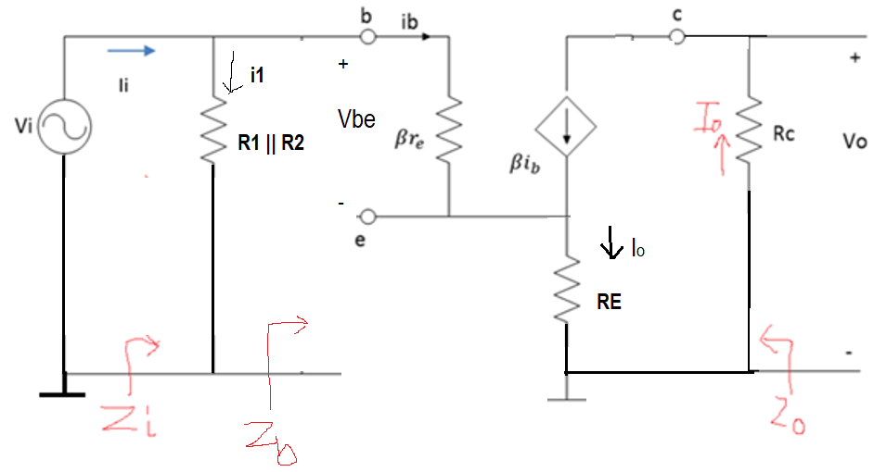

$$A_{v}=\frac{v_{o}}{v_{i}}=\frac{-R_{c}}{(r_{e}+R_{E})}$$

In this expression we do not know the value of $r_{e}$, thus it must be determined as follows,

$$A_{v}(r_{e}+R_{E})=-R_{c}$$

$$(r_{e}+R_{E})=-R_{c}/A_{v}$$

$$r_{e}=-\frac{R_{c}}{A_{v}}-R_{E}$$

For Rc=4.7 k, Av=-13, RE=350 Ohm=0.35 kOhm, we have

$$r_{e}=-\frac{4.7k}{\left(-13\right)}-0.35k=0.3615k-0.35k=0.0115k=11.5 Ohm$$

Now, let us remember that

$$r_{e}=\frac{V_{T}}{I_{EQ}}$$

where $V_{T}=26 mV$ (at room temperature 27 Co). Then, the DC emitter current $I_{EQ}$ at operatimg point Q is

$$I_{EQ}=\frac{V_{T}}{r_{e}}=\frac{26 mV}{11.5 Ohm}=2.2609 mA$$

$$I_{BQ}=\frac{I_{EQ}}{β+1}=\frac{2.2609 mA}{101}=0.0224 mA=22.4 μA$$

$$I_{CQ}=βI_{BQ}=\left(100\right)\left(0.0224mA\right)=2.24 mA$$

Now, we can write a KVL from the DC eqvn. circuit (it is regiven in the following)

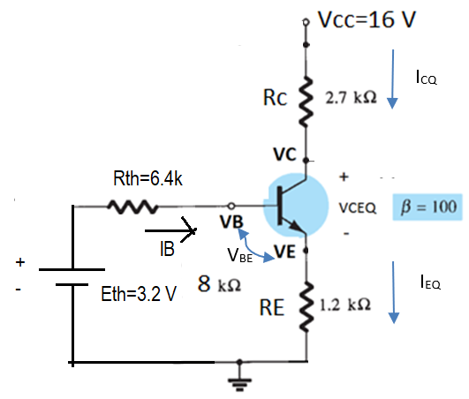

$${-E}_{th}+R_{th}I_{BQ}+V_{BE}+I_{EQ}R_{E}=0$$

where we remember that

$$E_{th}=\frac{V_{cc}}{(R_{1}+R_{2})}R_{2}$$

$$R_{th}=R_{1}||R_{2}=\frac{R_{1}R_{2}}{(R_{1}+R_{2})}$$

Putting these into the above eqn. we obtain

$$-\frac{V_{cc}}{(R_{1}+R_{2})}R_{2}+\frac{R_{1}R_{2}}{(R_{1}+R_{2})}I_{BQ}+V_{BE}+I_{EQ}R_{E}=0$$

Arranging this eqn. gives us

$$\frac{{(R}_{1}R_{2}I_{BQ}-V_{cc}R_{2})}{(R_{1}+R_{2})}+V_{BE}+I_{EQ}R_{E}=0$$

$$V_{cc}R_{2}-R_{1}R_{2}I_{BQ}=(R_{1}+R_{2})(V_{BE}+I_{EQ}R_{E})$$

$$V_{cc}=\frac{\left(R_{1}+R_{2}\right)\left(V_{BE}+I_{EQ}R_{E}\right)+R_{1}R_{2}I_{BQ}}{R_{2}}$$

For R1=119.67 k, R2=10 k, VBE=0.7 V, IEQ= $2.2609 mA$, RE=0.35 k, IBQ= $0.0224 mA$,

$V_{cc}=$ 22.00 V.